Contents

1. Creating a Pay Code Group 1
2. Editing a Pay Code group 3

Knowledge Article: Pay Code Access Groups

Creating a Pay Code Group

WFM Dashboard > WFM Configuration > Configuration Settings

- Click on 'Pay Code Groups' | 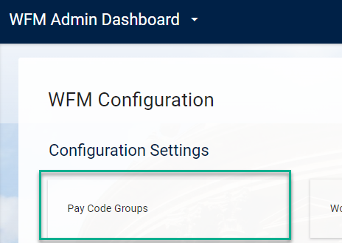

- Click on ADD GROUP

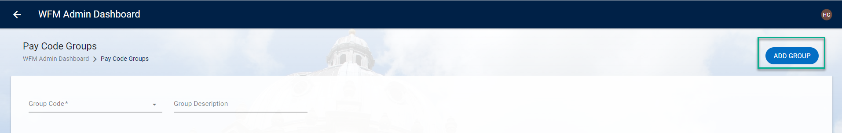

- Enter a Group Code (max 6 characters) and Group Description (max 40 characters)

 Refer to existing Pay Code Groups to check the formatting for the code and description
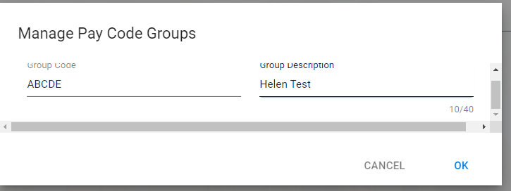

- SAVE

- To add Pay Codes to the new group click on ADD

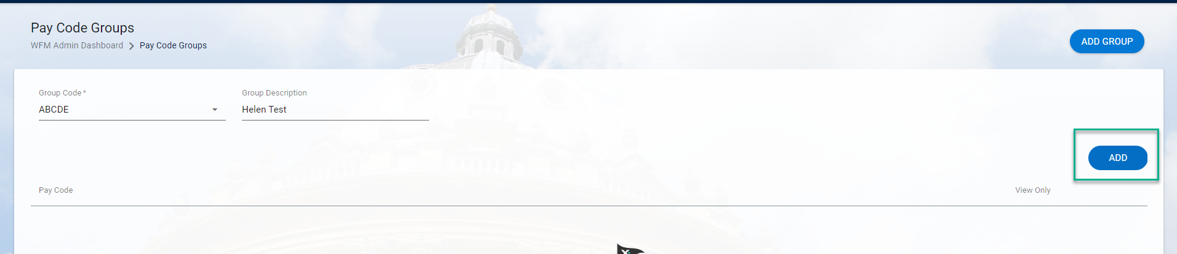

- Choose a pay code from the drop down list

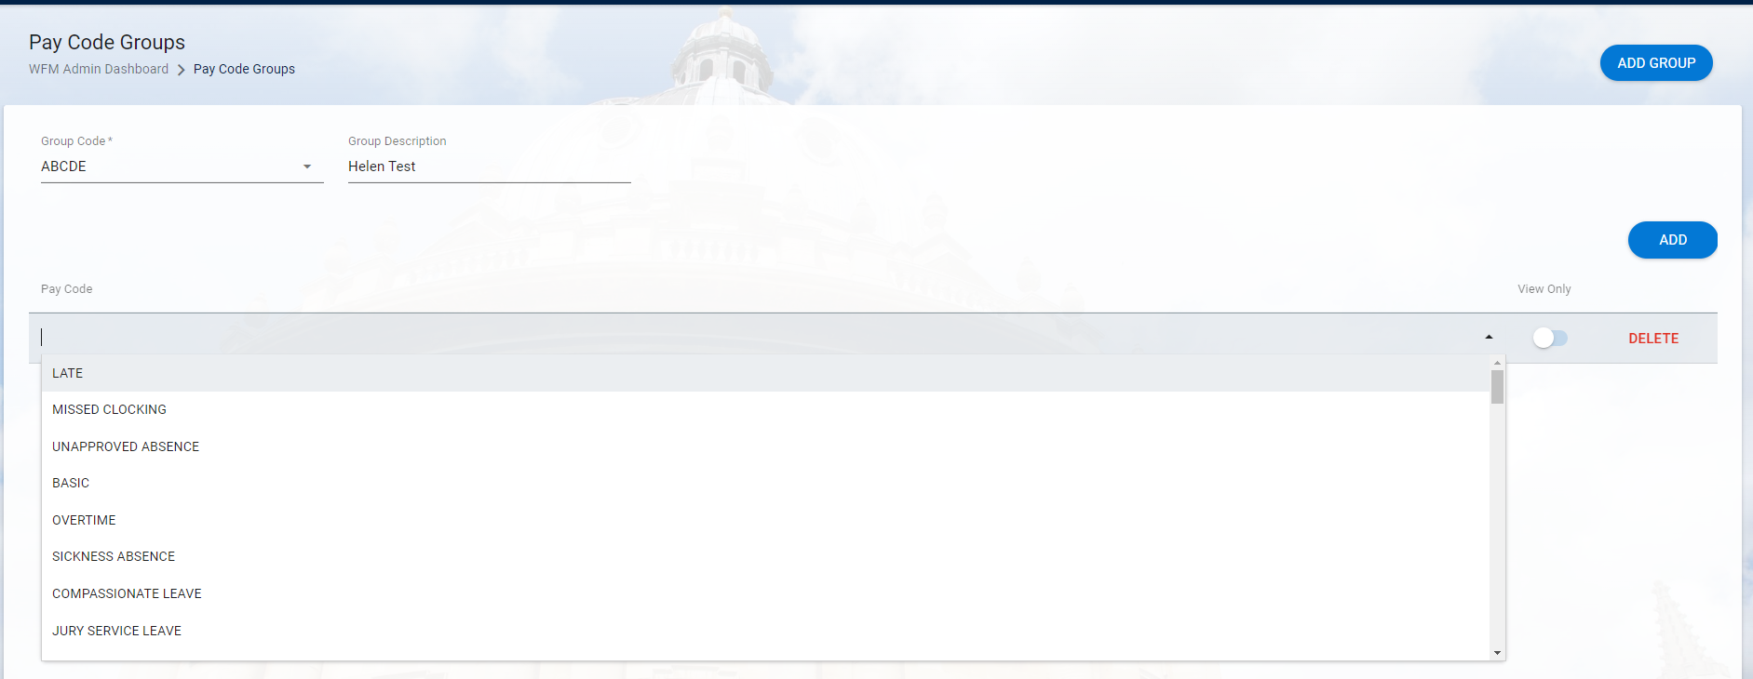

- Repeat steps 6 and 7 for each pay code to be added to the group.

- SAVE

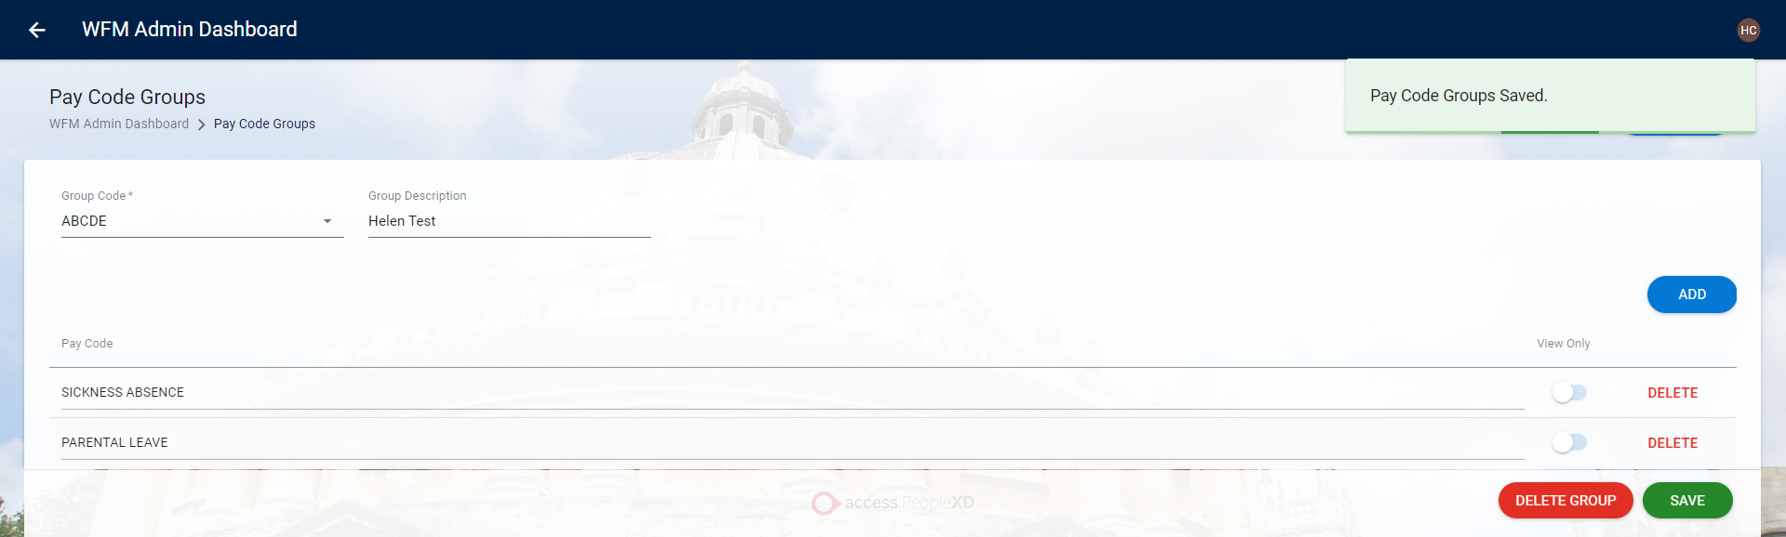

Editing a Pay Code group

WFM Dashboard > WFM Configuration > Configuration Settings

- Click on 'Pay Code Groups' | 

- Search for the group to be edited

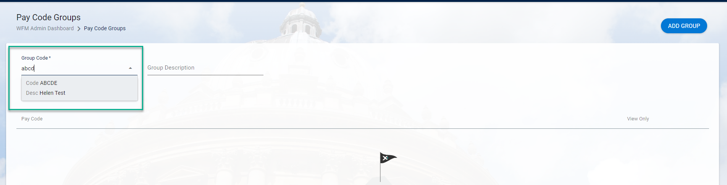

- Add or delete pay codes as required

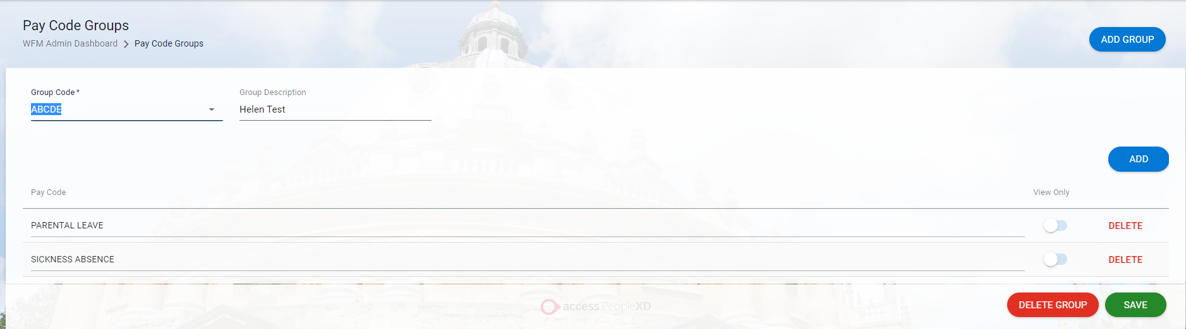

- SAVE

